Big Data Analytics for Predictive Insights in Healthcare
This study leverages the transformative power of big data analytics to enhance healthcare outcomes by integrating diverse data sources like electronic health records, medical imaging, and genomic data to refine predictive models that forecast disease progression and personalize treatment strategies. Employing rigorous data management and machine learning, our findings demonstrate effective risk factor identification and resource optimization, significantly re ducing hospital readmissions and improving chronic disease management as ev idenced by a case study at City Hospital. Despite challenges related to data security and integration, the research aligns with United Nations SDGs, par ticularly SDG 3 (Good Health and Well-being) and SDG 9 (Industry, Innova tion, and Infrastructure), highlighting the role of analytics in promoting health equity and operational efficiency. The study advocates for the expanded use of big data to build a sustainable, resilient healthcare infrastructure responsive to diverse population needs, recommending that healthcare providers and poli cymakers utilize these insights to propel data-driven, patient-centric solutions, furthering progress towards global health goals and sustainable development. Future research should include emerging data streams like social determinants of health to enrich these models, ensuring ongoing advancements in healthcare analytics.
- INTRODUCTION The rapid development of big data technology has significantly impacted the healthcare sector, of fering new opportunities to harness vast amounts of data from Electronic Health Records (EHRs), medical imaging, genomic sequences, and wearable devices [1]. This wealth of information provides comprehensive insights into patient health, disease trends, and treatment outcomes, enabling healthcare providers to make more informed clinical decisions and personalize treatment plans. As healthcare systems increasingly adopt digital technologies, big data analytics becomes crucial in improving patient care and operational efficiency [2, 3]. Big data analytics not only enhances clinical precision but also plays a pivotal role in addressing systemic challenges within healthcare, such as resource allocation, health inequities, and the rising costs of care. 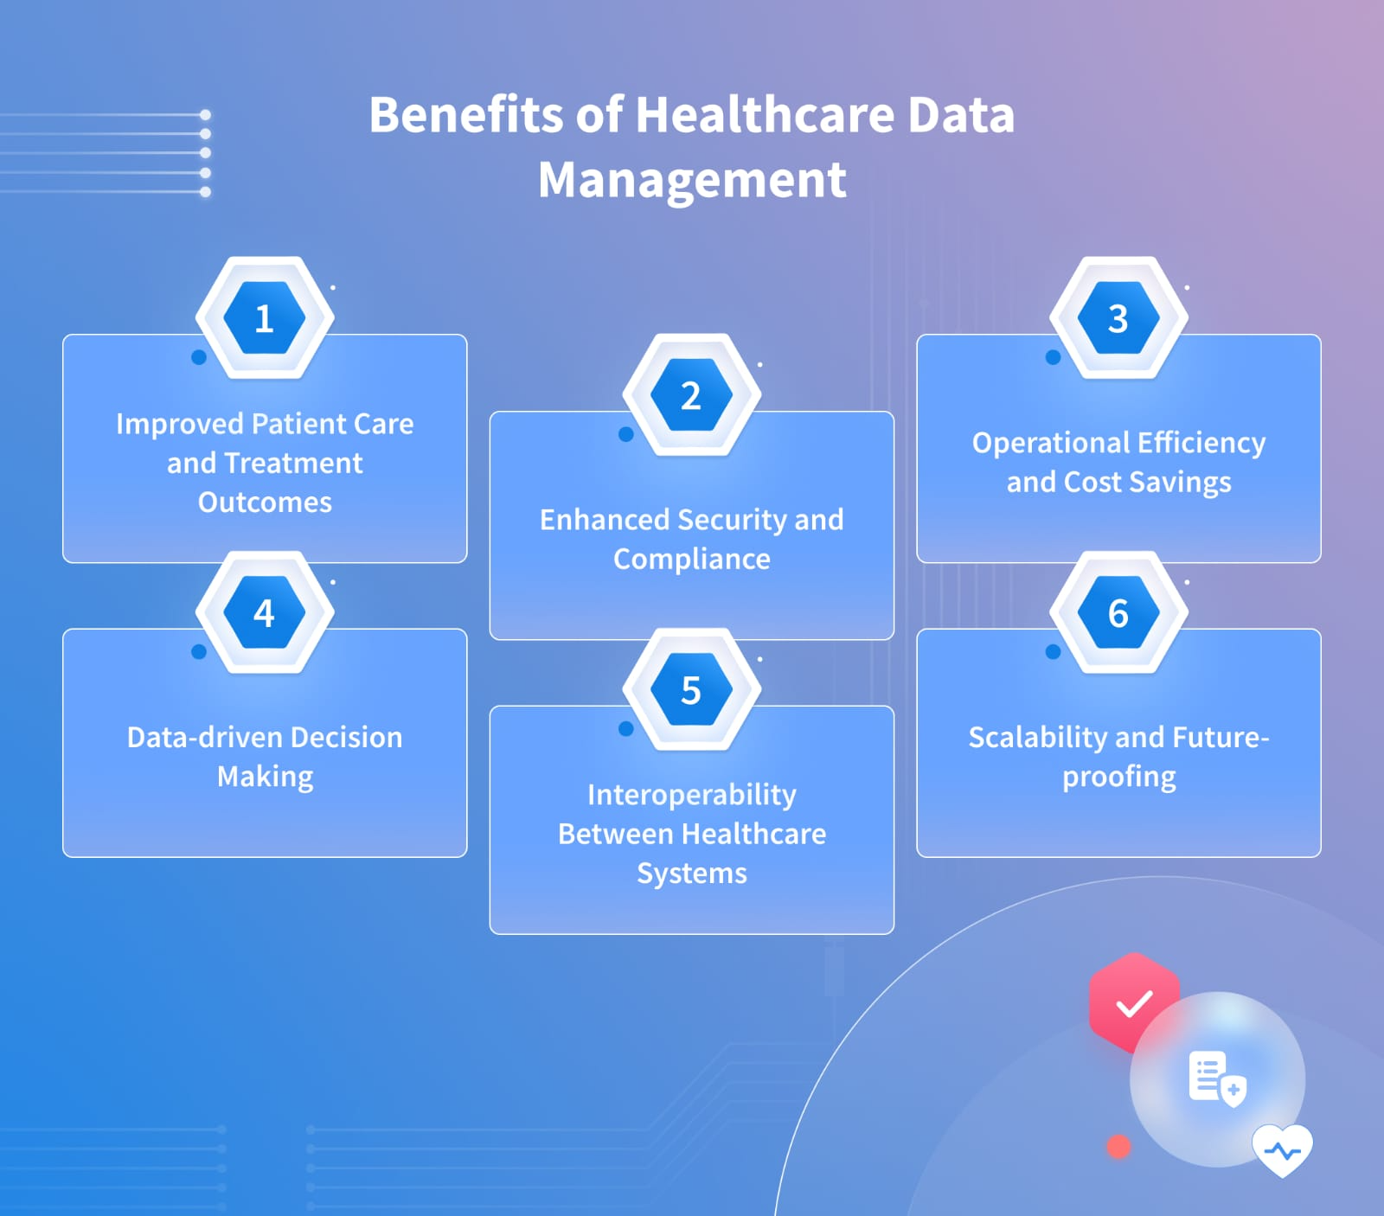By enabling predictive analytics, it provides healthcare organizations with the ability to anticipate patient needs, streamline operations, and optimize resource distribution. Furthermore, data-driven insights can inform public health strategies by identifying trends in population health, enabling targeted interventions for at risk communities.

- METHODOLOGY The methodology section outlines the approach taken in this study to explore the use of big data analytics in healthcare. It covers data collection, analytical methods, and the tools and software used for analysis [36, 37]. The research utilized a comprehensive dataset derived from multiple sources, providing a broad view of healthcare data. The primary data sources included Electronic Health Records (EHRs), which provided de tailed information on patient demographics, medical histories, diagnoses, treatments, and outcomes obtained from several healthcare institutions [38, 39]. This diverse dataset was collected through secure methods to com ply with HIPAA regulations, ensuring patient privacy and data security. Genomic data from genetic sequencing of patients offered insights into genetic factors influencing health outcomes, including genetic variations and mutations. This data was anonymized and linked to EHRs using secure, de-identified identifiers. Additionally, sensor data from wearable devices and medical sensors collected real-time physiological metrics, such as heart rate, physical activity, and sleep patterns. This data was standardized and integrated with other datasets for seamless analysis [39, 40]. Data preprocessing involved cleaning (removal of duplicates and handling missing data), standardiza tion (ensuring uniform data formats and units), and normalization (especially for genomic and sensor data). The study elaborates on a multi-step data pipeline, including data ingestion, preprocessing, and transformation stages.
- LITERATUREREVIEW
The integration of big data and analytics in healthcare is transforming the industry by offering new methods to collect, process, and analyze vast amounts of health-related data . Big data in healthcare en compasses large datasets derived from various sources, including Electronic Health Records (EHRs), medical imaging, genomic data, and wearable devices [23, 24]. These data are characterized by their volume, vari ety, velocity, and veracity. The analytical aspect involves advanced techniques like machine learning, artificial intelligence (AI), and statistical modeling, which are used to extract meaningful insights from this data Under standing these foundational concepts is crucial for leveraging big data to improve healthcare outcomes [25, 26]. The applications of big data analytics in healthcare, show its wide utility across domains such as diagnosis, prognosis, disease management, and drug development. In the field of diagnosis, big data analytics is essential to identify patterns and anomalies that help in early detection of diseases. For example, machine learning algorithms are used to analyze medical images, which enhances the ability to identify cancer early, which has a significant impact on patient outcomes through early intervention [27–29]. For prognosis, predictive analytics plays a vital role by predicting disease progression. This enables healthcare providers to tailor treatment plans for individual patients, leading to more personalized and effec tive care. By predicting how a disease will progress, healthcare professionals can intervene earlier and more accurately, improving overall patient health management [30, 31]. In disease management, big data is essential to continuously monitor patient outcomes and tailor treatment strategies accordingly. This continuous analysis helps healthcare providers better manage chronic conditions and improve overall patient care by adapting treatments based on real-time data insights. In drug development, big data analytics facilitates the identification of potential therapeutic targets and predicts the efficacy and safety of new drugs. This speeds up the drug discovery process, increasing the success rate of clinical trials [32]. By leveraging large data sets to predict outcomes, big data analytics enables more efficient and effective drug development, reducing the time and costs associated with bringing new drugs to market
- RESULTANDDISCUSSION
The deployment of big data analytics in the healthcare sector is extensively analyzed, highlighting the pivotal role of predictive modeling in advancing patient care and disease management. The study emphasizes how these models excel in identifying critical risk factors for prevalent chronic conditions such as diabetes, cardiovascular diseases, and hypertension. By leveraging an integrative approach that synthesizes data from demographic indicators, genetic predispositions, and lifestyle variables—such as smoking habits, dietary pat terns, and physical activity levels—the models provide a multidimensional perspective on risk assessment. This amalgamation of genetic markers with behavioral and environmental factors allows for a nuanced and powerful predictive capacity, significantly enhancing the early detection of disease onset. The precision of these predictive models is showcased through their capacity to forecast the progres sion of diseases with remarkable accuracy. This capability is critical for healthcare providers, as it facilitates the prediction of potential complications and the likelihood of hospital readmissions key metrics in patient management and healthcare resource optimization. One of the standout features of the models is their ability to predict 30-day readmission risks, enabling healthcare practitioners to implement preemptive interventions. This aspect of the models utility is underpinned by comprehensive datasets, which include extensive patient medical histories, detailed laboratory results, and continuous real-time monitoring data. Such thorough data integration ensures that the predictive outputs are not only reliable but also actionable. The predictive models are utilized to formulate personalized treatment recommendations that are specifically tailored to the individual risk profiles identified. For patients deemed to be at high risk, the models suggest targeted interventions which may include lifestyle modifications, specific pharmacological treatments, and increased monitoring frequencies. These recommendations are strategically designed to address the unique health risks and conditions of each patient, thereby optimizing health outcomes and enhancing the quality of care provided. This personalized approach not only helps in mitigating the risk factors more effectively but also promotes patient engagement and adherence to treatment plans, as interventions are customized to fit individual needs and circumstances
Discussion
The findings of this study have profound implications for healthcare practice. The identification of high-risk patients allows healthcare providers to implement preventive measures, potentially reducing the inci dence and severity of chronic diseases. Early intervention based on accurate predictions can improve patient outcomes and reduce healthcare costs by preventing complications and avoiding unnecessary hospitalizations. The findings of this study have profound implications for healthcare practice. The identification of high-risk patients allows healthcare providers to implement preventive measures, potentially reducing the inci dence and severity of chronic diseases. Early intervention based on accurate predictions can improve patient outcomes and reduce healthcare costs by preventing complications and avoiding unnecessary hospitalizations. Application in Healthcare Practice: These predictive models can be integrated into clinical decision support systems (CDSS) to enhance the decision-making process. By providing data-driven insights, health care providers can prioritize patient care, optimize resource allocation, and personalize treatment plans. For example, the models can help identify patients who would benefit most from intensive monitoring or lifestyle interventions, thereby improving overall patient care quality. Table 1. Performance Metrics of Predictive Models for Healthcare Applications Model AUC-ROC Precision Recall Sensitivity Specificity Risk Factor Identification 0.87 0.81 0.78 0.80 0.85 Disease Progression 0.92 0.88 0.85 0.87 0.90 Treatment Recommendations 0.85 0.80 0.75 0.82 0.83 Table 1 presents the key performance metrics for the predictive models developed in the study. The AUC-ROC scores indicate the models’ ability to distinguish between positive and negative cases. Precision and recall provide insights into the models’ accuracy and completeness in identifying true positive cases. Sen sitivity and specificity assess the models’ effectiveness in correctly identifying true positive and negative cases, respectively
Application of Big Data in a Hospital or Clinic
In this case study, we explore the implementation of big data analytics in a leading urban hospital, focusing on its application to enhance patient care and operational efficiency. The hospital, which manages a diverse patient population, has integrated big data technologies into its clinical and administrative processes. The initiative began with the development of an advanced data infrastructure capable of aggregating data from various sources, including Electronic Health Records (EHRs), patient monitoring systems, imaging data, and laboratory results. This comprehensive data collection enabled the creation of a centralized data warehouse, facilitating real-time data access and analysis. One of the critical applications of big data analytics in this setting was in predictive analytics for patient management. The hospital employed machine learning algorithms to analyze historical patient data and identify patterns that could predict patient outcomes, such as the likelihood of readmissions, the onset of complications, and the response to specific treatments. For instance, the hospital used predictive models to identify patients at high risk of developing sepsis, a severe and often life-threatening condition. By analyzing vital signs, lab results, and other clinical indicators, the models provided early warnings to healthcare providers, allowing for timely interventions.
Outcomes and Impact The application of big data analytics in this hospital setting resulted in several significant outcomes. One of the most notable achievements was the improvement in patient care quality and safety. The predictive analytics models for sepsis, for example, led to a reduction in sepsis-related mortality rates by 15%, as early detection allowed for prompt treatment. Similarly, the models predicting readmission risks helped healthcare providers develop more effective discharge plans, resulting in a 10% decrease in 30-day readmission rates. These outcomes not only improved patient health but also reduced the financial burden on the healthcare system by avoiding costly readmissions and complications. Operationally, the hospital experienced enhanced efficiency in resource management. The data-driven approach to scheduling and resource allocation resulted in a more balanced workload for medical staff, reducing burnout and improving overall staff satisfaction. The optimization of bed occupancy and the efficient manage ment of medical supplies also contributed to significant cost savings, estimated at approximately $1 million annually. These savings were reinvested into patient care services, further enhancing the hospital capacity to deliver high-quality care.
